**Option #1: Custom Functions in R - Histograms**

1. Write a custom R function that inputs a temperature in Fahrenheit Fo and converts to Celsius Co. The relationship is Co = 5(Fo – 32)/9.  
     
     
     
   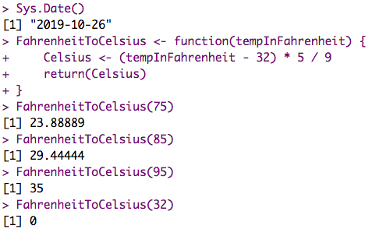
2. Write a custom R function that computes the sum of squares of two numbers.  
     
     
   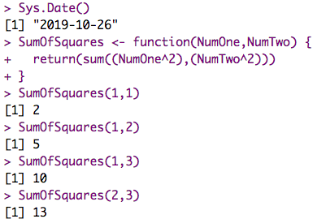
3. Write a custom R function that takes any univariate dataset and calculates the mean, minimum, maximum, and standard deviation.

  
  
  
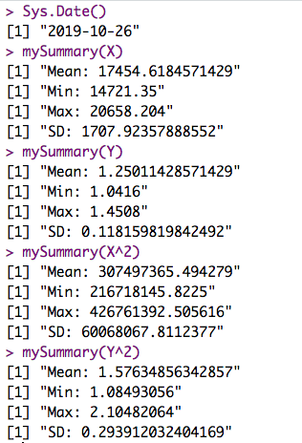

1. In statistics, a dataset needs to be transformed in order to meet certain assumptions. Write a custom R function that takes any univariate dataset and creates a histogram of the raw dataset and a histogram of the log-transformed dataset.    
     
   

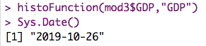  
   
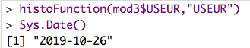  
   
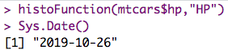  
 

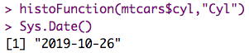

 

1. Write a custom R function of your own. Describe what your function does and produce the output.



I wrote a custom function that takes in two vectors and automates the process of calculating and plotting the linear model, as well as printing the summary of the model.

